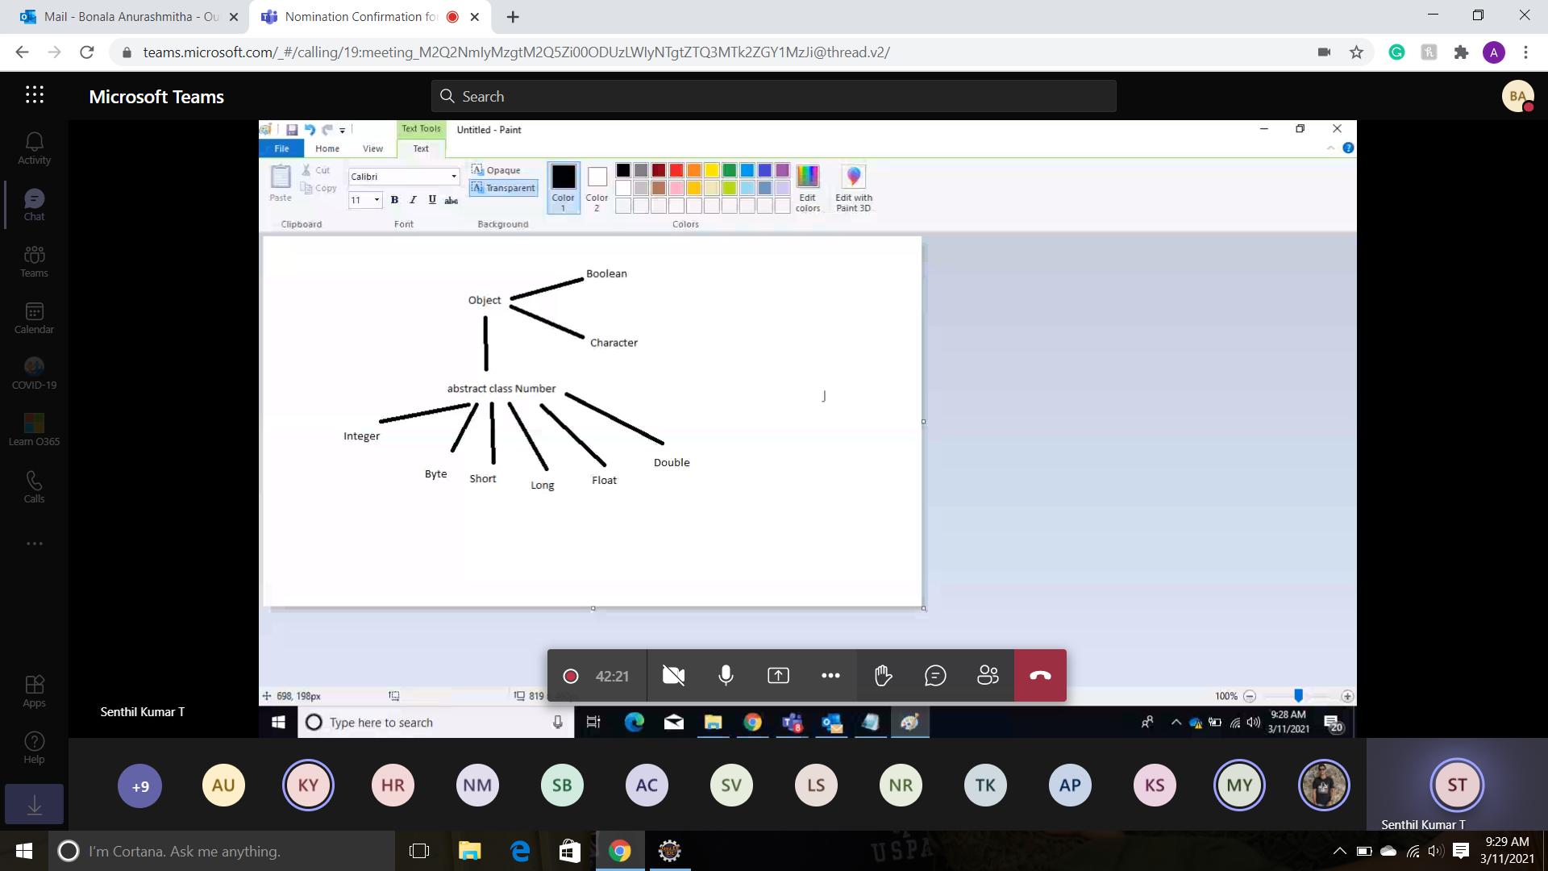

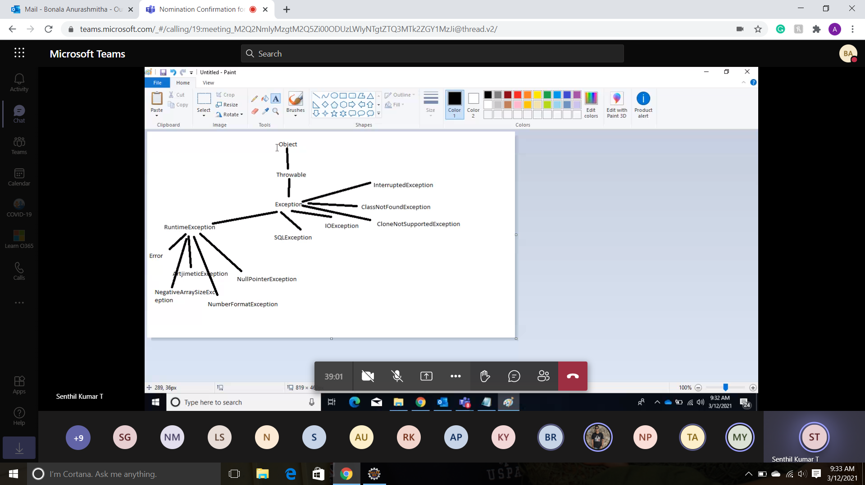

public void go() {

String o = ""; z:

for(int x = 0; x < 3; x++) {

for(int y = 0; y < 2; y++) {

if(x==1)

break;

if(x==2 && y==1)

break z;

o = o + x + y;

}

}

System.out.println(o);

}

**What is the result when the go() method is invoked?**

A. 00

B. 0001

C. 000120

D. 00012021

E. Compilation fails.

F. An exception is thrown at runtime.

**Correct Answer: C**

1. public class A{

2. public void method1() {

3. try {

4. B b = new B();

5. b.method2();

6. //more code here

7. } catch (TestException te){

8. throw new RuntimeException(te);

9. }

10. }

11.}

1. public class B{

2. public void method2() throws TestException {

3. //more code here

4. }

5. }

1. class TestException extends Exception {

2. }

A. Line 33 must be called within a try block.

B. The exception thrown by method1 in class A is not required to be caught.

C. The method declared on line 31 must be declared to throw a RuntimeException.

D. On line 5 of class A, the call to method2 of class B does not need to be placed in a try/catch block.

**Correct Answer: B**

Given: Float pi = new Float(3.14f); if (pi > 3) {

System.out.print("pi is bigger than 3. "); } else {

System.out.print("pi is not bigger than 3. "); } finally {

System.out.println("Have a nice day."); } What is the result?

A. Compilation fails. B. pi is bigger than 3. C. An exception occurs at runtime. D. pi is bigger than 3. Have a nice day. E. pi is not bigger than 3. Have a nice day.

**Correct Answer: A**

|  |  |
| --- | --- |
| 1  2  3  4  5  6  7  8  9  10  11  12  13  14 | <strong>public class Test {</strong>  <strong>public static void printValue(int i, int j, int k){</strong>  <strong>System.out.println("int");</strong>  <strong>}</strong>    <strong>public static void printValue(byte...b){</strong>  <strong>System.out.println("long");</strong>  <strong>}</strong>    <strong>public static void main(String... args) {</strong>  <strong>byte b = 9;</strong>  <strong>printValue(b,b,b);</strong>  <strong>}</strong>  <strong>}</strong> |

Ans: int

|  |  |
| --- | --- |
| 1  2  3  4  5  6  7  8  9  10  11  12  13  14  15  16  17  18  19  20  21  22  23  24  25  26  27  28  29 | <strong>class A {</strong>    <strong>A(String s) {</strong>    <strong>}</strong>    <strong>A() {</strong>    <strong>}</strong>    <strong>}</strong>    <strong>1. class B extends A {</strong>    <strong>2. B() { }</strong>    <strong>3. B(String s) {</strong>    <strong>4. super(s);</strong>    <strong>5. }</strong>    <strong>6. void test() {</strong>    <strong>7. // insert code here</strong>    <strong>8. }</strong>    <strong>9. }</strong> |

A.A a = new B();

B.A a = new B(5);

C.A a = new A(String s);

D.All of the above

Answer :

A is the correct answer.

|  |  |
| --- | --- |
| 1  2  3  4  5  6  7  8  9  10  11  12  13  14  15  16  17  18  19  20  21  22  23  24  25  26  27  28  29  30  31  32  33  34  35  36  37  38  39  40  41  42  43  44  45  46  47  48  49  50  51 | <strong>public class A {</strong>    <strong>public void printValue(){</strong>    <strong>System.out.println("Value-A");</strong>    <strong>}</strong>    <strong>}</strong>    <strong>public class B extends A{</strong>    <strong>public void printNameB(){</strong>    <strong>System.out.println("Name-B");</strong>    <strong>}</strong>    <strong>}</strong>    <strong>public class C extends A{</strong>    <strong>public void printNameC(){</strong>    <strong>System.out.println("Name-C");</strong>    <strong>}</strong>    <strong>}</strong>    <strong>1. public class Test{</strong>    <strong>2. public static void main (String[] args) {</strong>    <strong>3. B b = new B();</strong>    <strong>4. C c = new C();</strong>    <strong>5. newPrint(b);</strong>    <strong>6. newPrint(c);</strong>    <strong>7. }</strong>    <strong>8. public static void newPrint(A a){</strong>    <strong>9. a.printValue();</strong>    <strong>10. }</strong>    <strong>11. }</strong> |

A.Value-A Name-B

B.Value-A Value-A

C.Value-A Name-C

D.Name-B Name-C

Answer :

B is the correct answer.

|  |  |
| --- | --- |
| 1  2  3  4  5  6  7  8  9  10  11  12  13  14  15  16  17  18  19  20  21  22  23  24  25  26  27  28  29  30  31  32  33  34  35  36  37  38  39  40  41  42  43  44  45  46  47  48  49  50  51 | <strong>public class A {</strong>    <strong>public void printName(){</strong>    <strong>System.out.println("Value-A");</strong>    <strong>}</strong>    <strong>}</strong>    <strong>public class B extends A{</strong>    <strong>public void printName(){</strong>    <strong>System.out.println("Name-B");</strong>    <strong>}</strong>    <strong>}</strong>    <strong>public class C extends A{</strong>    <strong>public void printName(){</strong>    <strong>System.out.println("Name-C");</strong>    <strong>}</strong>    <strong>}</strong>    <strong>1. public class Test{</strong>    <strong>2. public static void main (String[] args) {</strong>    <strong>3. B b = new B();</strong>    <strong>4. C c = new C();</strong>    <strong>5. b = c;</strong>    <strong>6. newPrint(b);</strong>    <strong>7. }</strong>    <strong>8. public static void newPrint(A a){</strong>    <strong>9. a.printName();</strong>    <strong>10. }</strong>    <strong>11. }</strong> |

A.Name-B

B.Name-C

C.Compilation fails due to an error on lines 5

D.Compilation fails due to an error on lines 9

Answer :

C is the correct answer.

**--throws and try,catch block**

